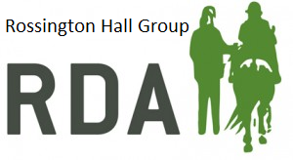  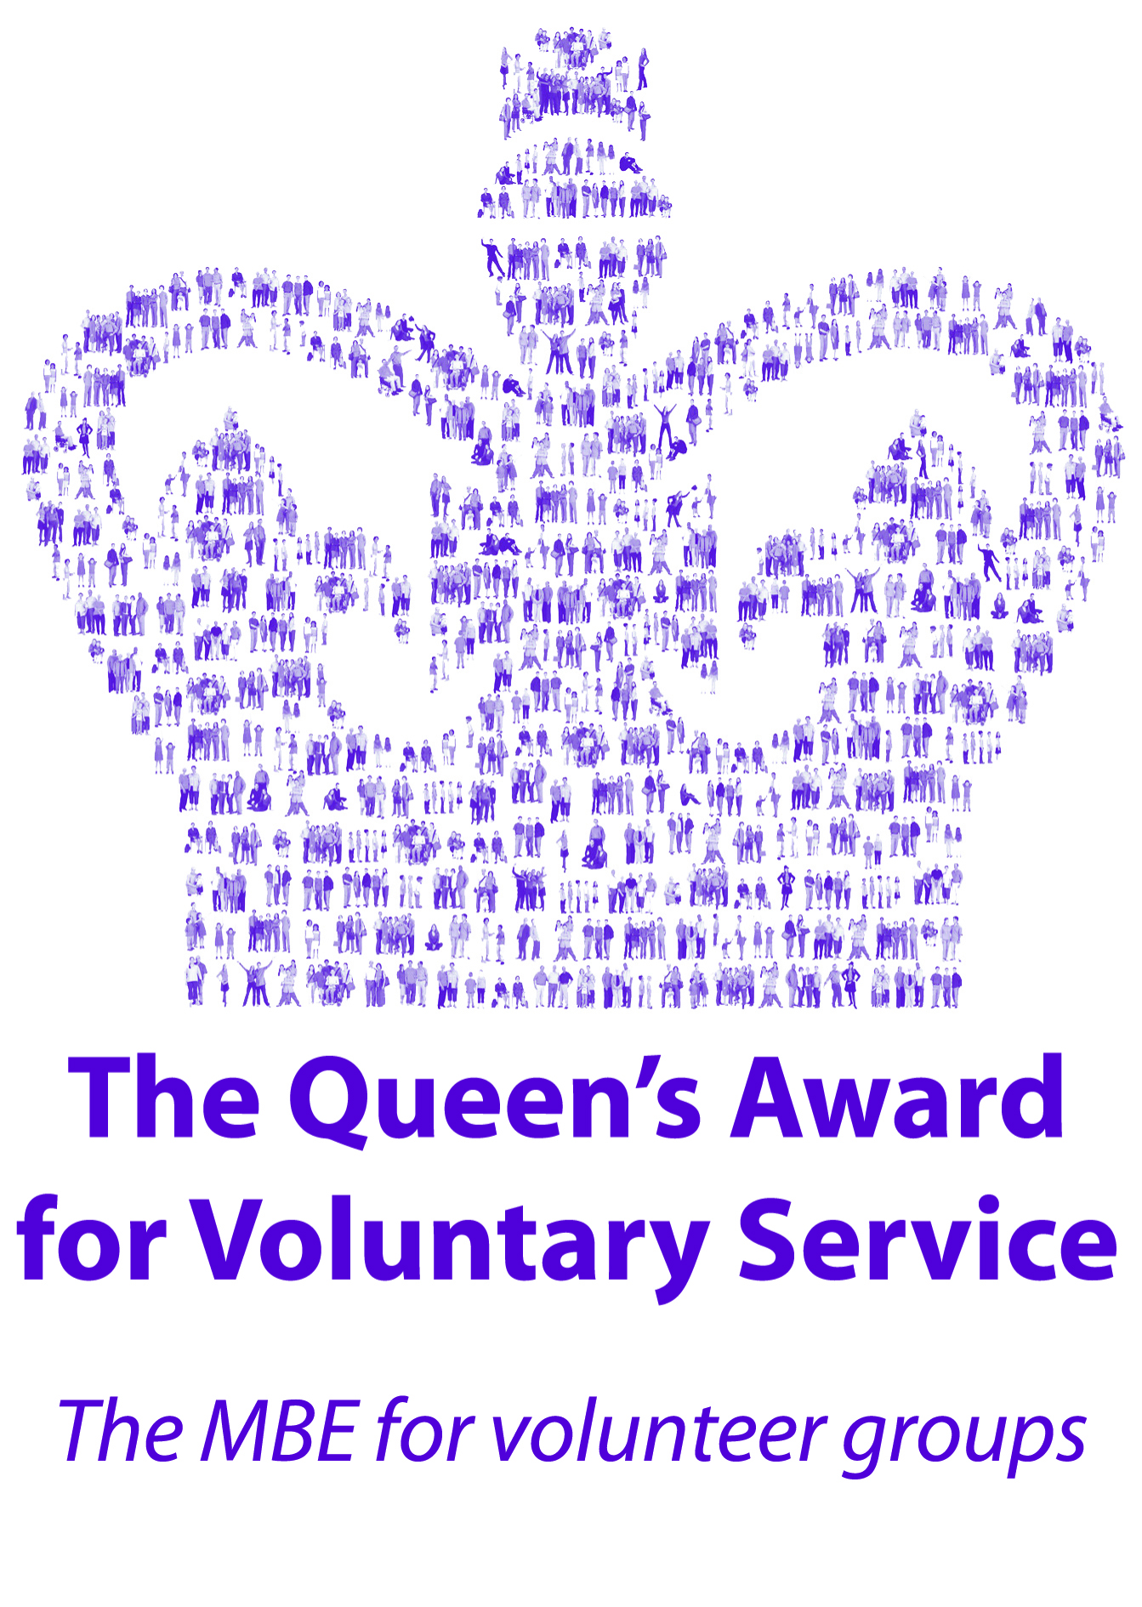 | Rossington Hall Group  Riding for the Disabled Association  National Horseracing College  The Stables  Great North Road  Doncaster DN11 0HN  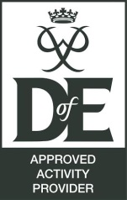
Chairman : Barry Edge  Secretary: Sharon Greenaway  Treasurer: Ann Jones  Registered Charity: 1074139 | Tel : 07798 906435  Email: info@rdarossington.co.uk www.rdarossington.co.uk  www.facebook.com/RossingtonHallRDA

Dear Barbara and Ladies,

On behalf of Riding for the Disabled at Rossington Hall Group I would like to thank you for your generous donation of £500 (five hundred pounds) to our charity.

The group offer riding 5 days a week and at present have 82 riders registered that attend on a regular basis. Hippotherapy is offered on Saturday by the qualified physiotherapist.
We are a self-funding charity that aim to provide a service that will help develop and support each rider to reach their full potential. Each lesson is based on riders’ ability and needs.
Two qualified Coaches are paid and all other tasks are carried out by volunteers 365 days a year.
Riders pay a small fee for lessons but all other costs are from donations or fundraising.
Your donation will go towards mud control mats for our paddock. This is a maintenance issue we have been trying to resolve for quite some time.

If any of your members would like to visit the group to see the work we do just get in touch and we will arrange it.
Thank you again for your support it is really appreciated.

Merry Christmas and Happy New Year to you all.

Ann
Trustee/ Treasurer.

